**Game Design Documents (using High Concept Document)**

**Tower Defense**

Kelompok :

Edward Bala Yansen 2101657606

Justin Delano 2101626973

William 2101647864

|  |  |  |
| --- | --- | --- |
| **Point** |  | **Description** |
| Judul Game |  | Tower Defense |
| High Concept |  | This game is a simple game where there are tower, spawner, the enemy and home. Player must protect the home from the enemy that approaching the home. |
| Features |  | This game has several features, first you can place your tower wherever the tile is empty, the tower you place has radius so whenever the enemy step on the radius, the tower will damage the enemy until they no longer step on the radius |
| Player Motivation |  | The purpose of this game is to prevent the enemy move towards our home that will result in our game health points decreasing and if it reaches zero you will lose the game or you can win by defeating all the enemies before they can reach your home |
| Genre |  | Simple stragey game |
| Target Customer |  | Strategy players who looking for simple strategy gameplay. |
| Unique Selling Points |  | * This game is simple and fun to play * Simple gameplay for newbie or gamer who are new to strategy game |
| Target Hardware |  | * OS: Win Xp 32 * Processor: Intel Pentium Dual Core E2140 1.60GHz / AMD Athlon 64 X2 Dual Core 4200+ * Graphics: AMD Radeon HD 6350 or NVIDIA GeForce 6800 GT * System Memory: 500 MB RAM * Storage: 10 MB Hard drive space * DirectX 9 Compatible Graphics Card |
| Design Goals |  | Simple: Very simple play-calling combined with simple controls makes this an easy game to learn and play. |
| Characters |  | * Tower : Made from triangle * Home : Made from triangle and square * Spawner : Cross red-colored symbol * Enemy : Red circle that walk through the home |
| How To Play |  | As a player you can place tower wherever on the tile as long there is no other symbol there, and prevent the enemy to reach your home |
| Objective Play |  | * Player can place tower * Player can pause the game * Enemy is able move towards your home * Tower can shoot one enemy at a time in radius |

[Screenshots]

1. Game Screenshot

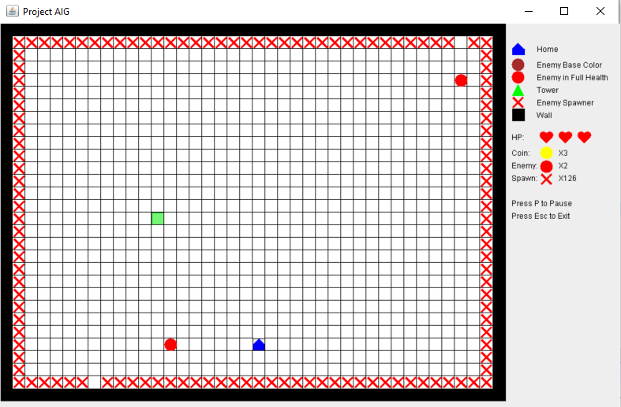

1. Lose the game

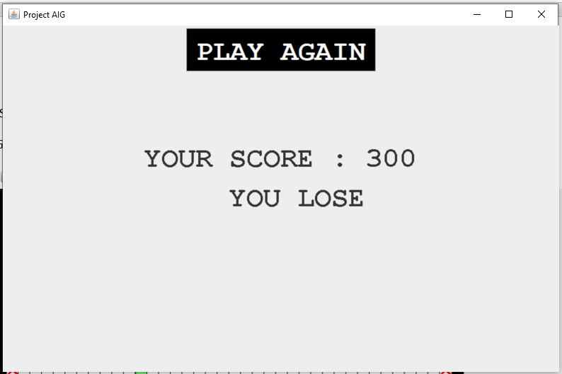

1. Placing tower

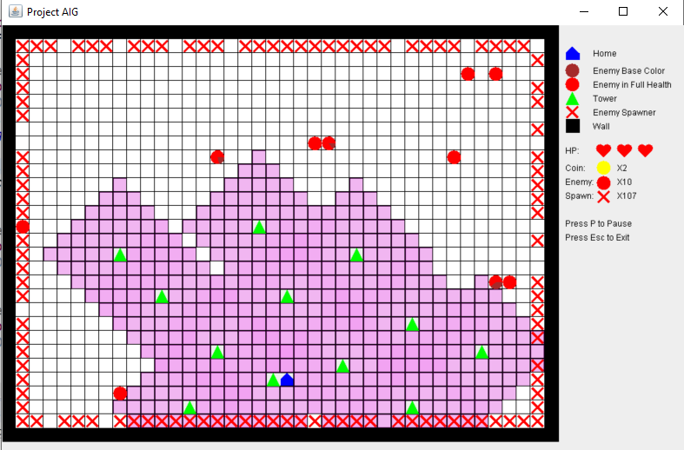

[Reference link]

-